Education for Life
Project Report for Team 10

Hien Nguyen
Christopher Lanphier
Carl Schott

Executive Summary
We created a web application to help the nonprofit group “Escape from Poverty” to distribute their educational materials to people in need.
Before, their website was very empty. The information was static. The website was not very useful.
Now, the website not only helps people in need to improve their lives at anytime from anywhere but also helps the management of the EFP group to add, edit and upload their educational materials.

Table of Contents

Executive Summary 2
Scope 4
Sprints, Milestones, and Deliverables 5
Iterations and Design 6
Final Deliverables 18
Conclusions 19
Appendices 20

Scope
Tasks | User stories
Create an account on GitHub.  Generate initial project on GitHub.  Create a database. | Developers need to access and update code on GitHub.
Deploy the project code onto the server in the subdomain.  Register SSL for the subdomain. | The website will be available 24/7 for users to access and view the lessons.  The developer can test the website during the development phase.
Implement CI/CD integration for delivery on GitHub. | Admins can make updates and changes to the websites.  Developers can update code on GitHub and see the changes to the website.
Create main dashboard view. | Admins use the dashboard to navigate to the pages where they can create, edit, and delete sections, modules, and lessons.  Participants navigate to sections, modules and lessons.
Create user authentication service for login. | All users can login and logout.
Create login, sign up, and forgot password pages. | All users need to reset password if they forgot password.  All users can register a new account.
List of user and user details | Admins can assign roles.
Create add and edit pages for Sections, Modules, and Lessons.  Delete and undo pages for Sections, Modules, and Lessons. | Admins can create, update, edit, delete and undo Sections, Modules, and Lessons.
Test the website functions with Cypress. | All users should have a flawless experience interacting with the website.
Table 1.
Sprints, Milestones and Deliverables

Sprint #1:
- Design wire frame, Install tools: IntelliJ IDE 2021, dB Schema, Git Hub.
- Learn together about spring boot, angular, Database, and WebStorm.
- Learn about Git and GitHub and practices to use GitHub.
Sprint #2:
- Generate the initial project.
- Applied what learn about Angular.
- Start build the home page and dashboard view.
- Set up webserver with Nginx.
- Start implement CI/CD.
Sprint #3:
- Build databases.
- Build the fronted pages: sign up, login and forget password.
- Build the display list of user, section, module and lesson.
- Build login backend system.
- Admin assign roles for user
- Deploy the project on the webserver.
Sprint #4:
- Build frontend edit, add and delete pages section, module and lesson.
- Build backend add and edit for section, module, lesson, mentor.
- Create SSL and redirect website and subdomain to port 443.
- Implement Cypress testing system.
Sprint #5:
- Build frontend the undo delete for section, module and lesson.
- Start to correct all problems found incorrect during testing phase.
- Add dialogs for all the actions to help the website respond to a user’s actions.
- Minor alterations to the website to make it look more professional.

Iterations and Design

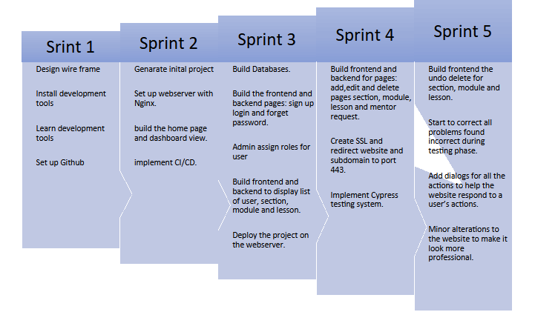

Chart 1.

Sprint 1:
Wire frame
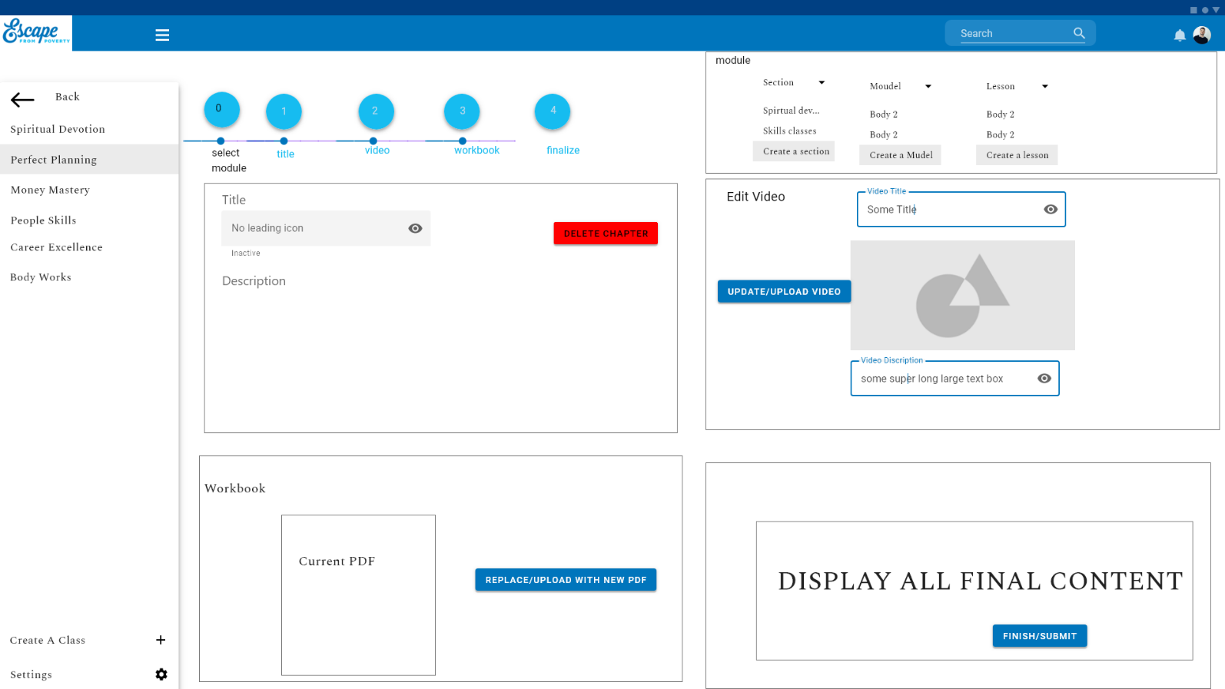

Sprint 2:
Home page
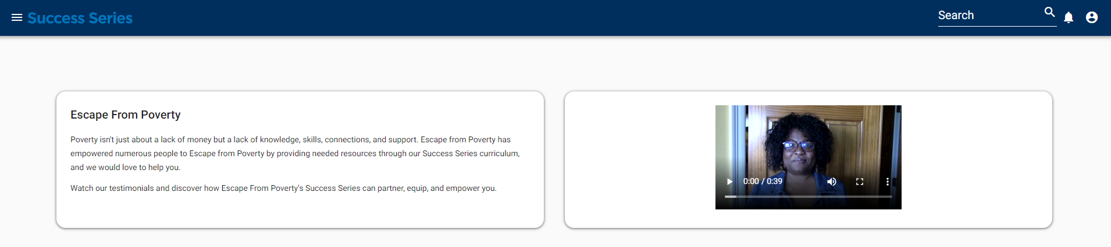
Dashboard
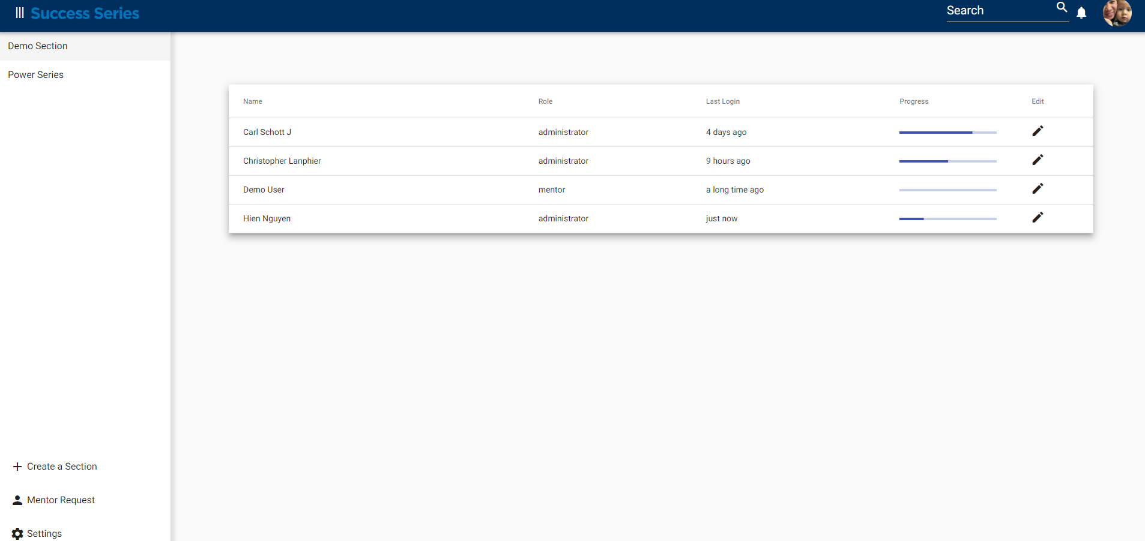
CI/CD: Continuous Integration & Continuous Delivery
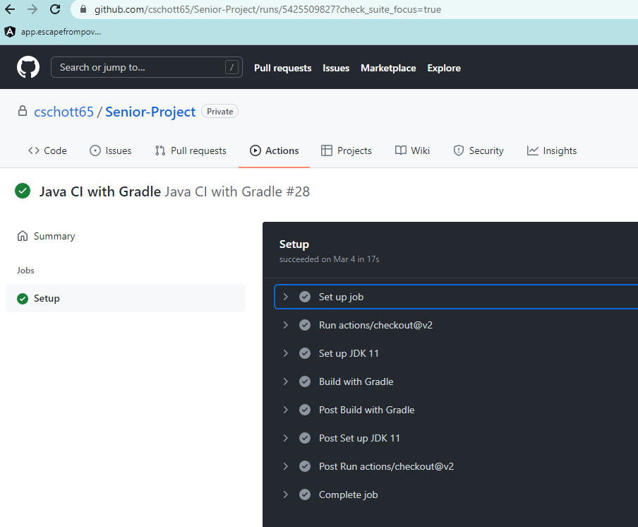
Sprint 3
Create database
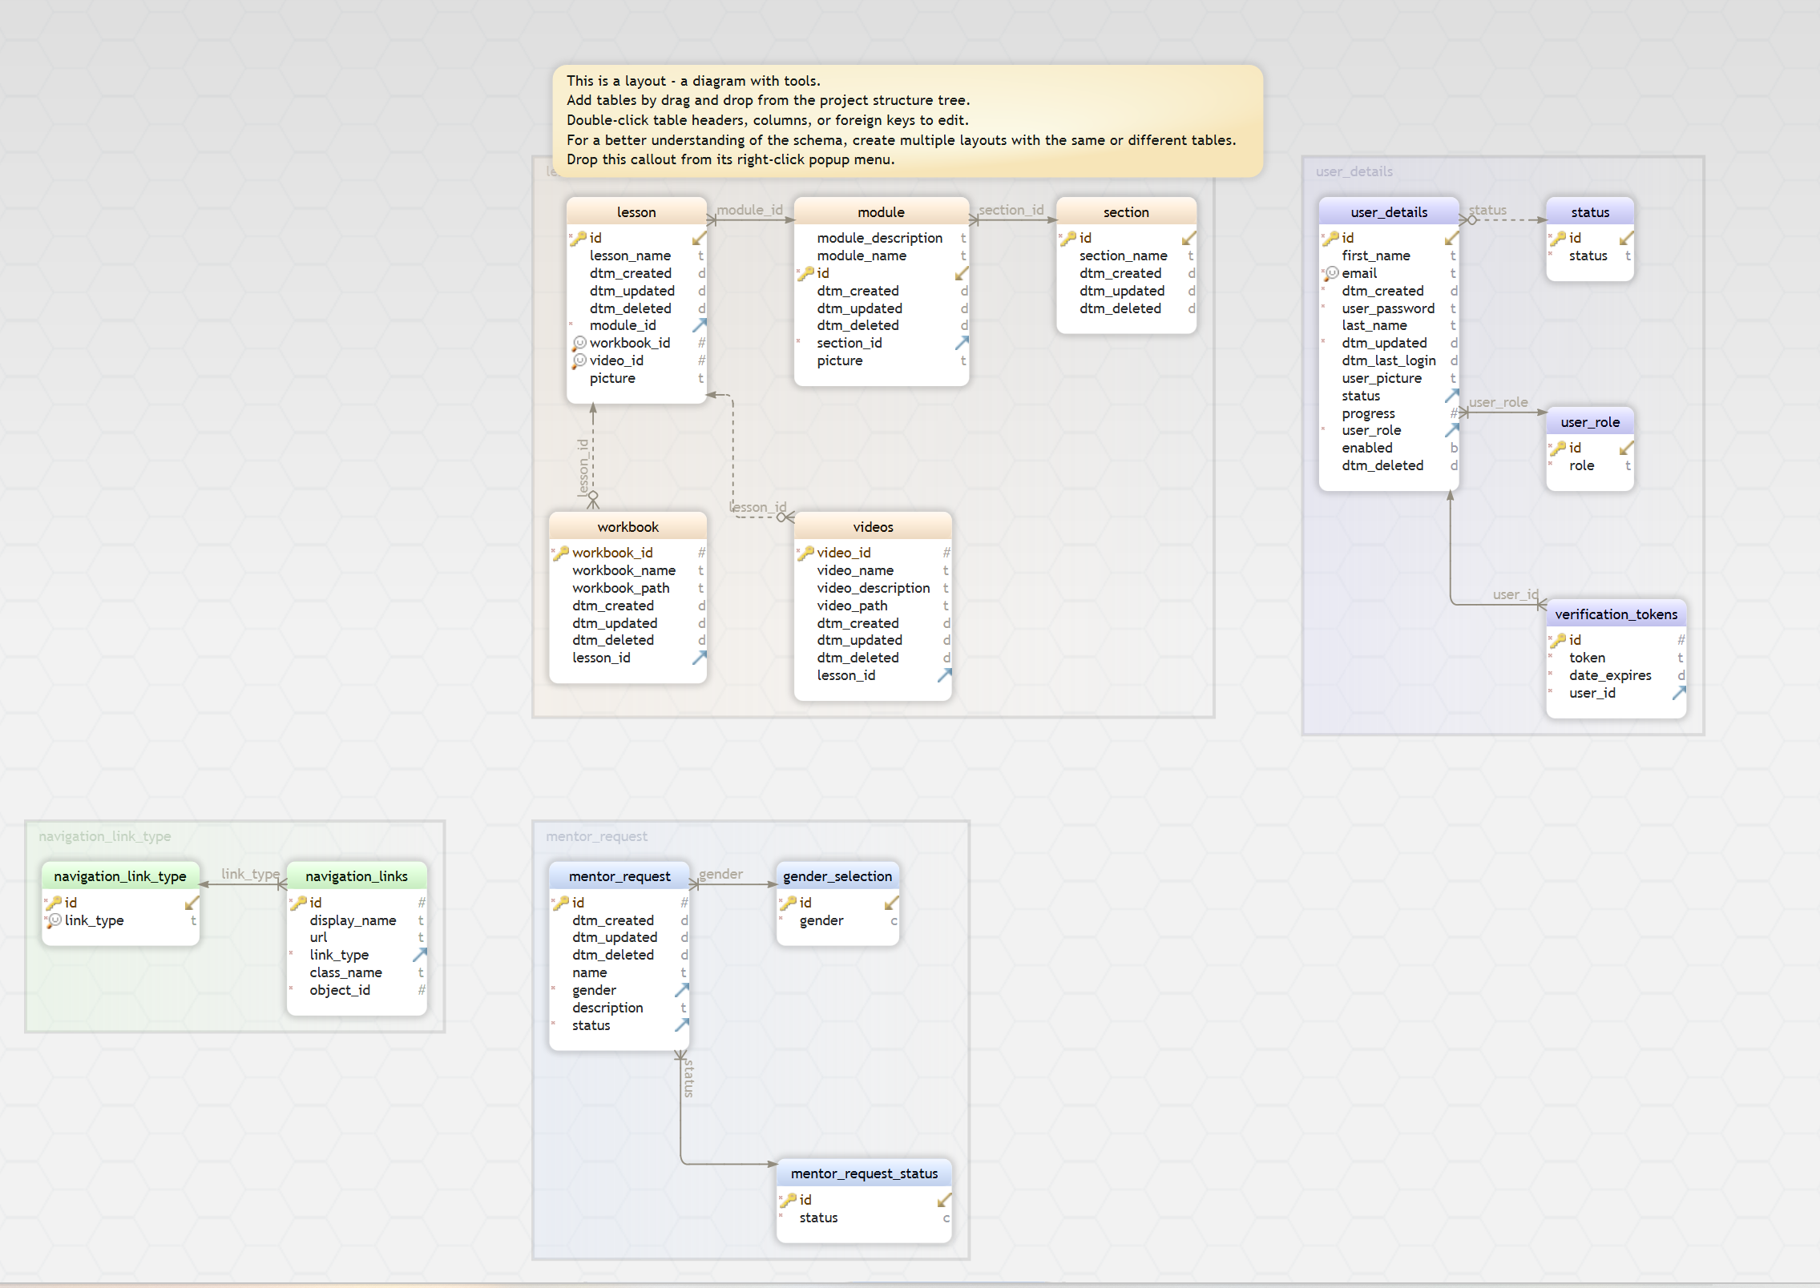

Deploy the project code on the webserver with Nginx in the subdomain app.escapefrompoverty.org.
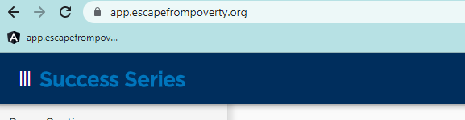

Frontend and backend for Sign up, Login, Forget Password page
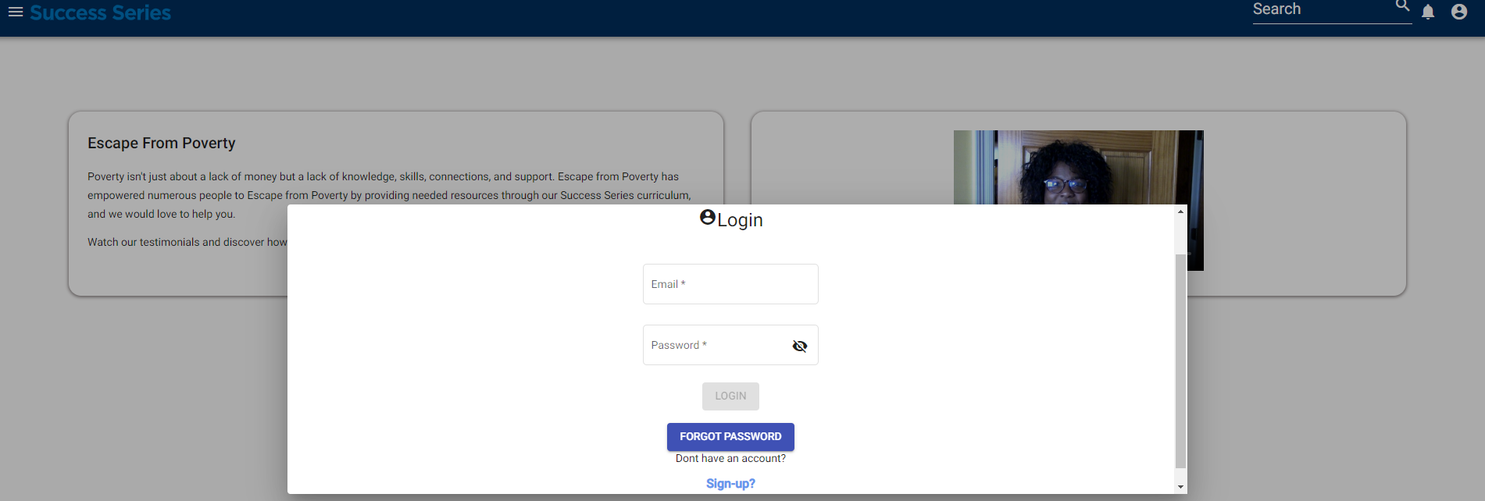
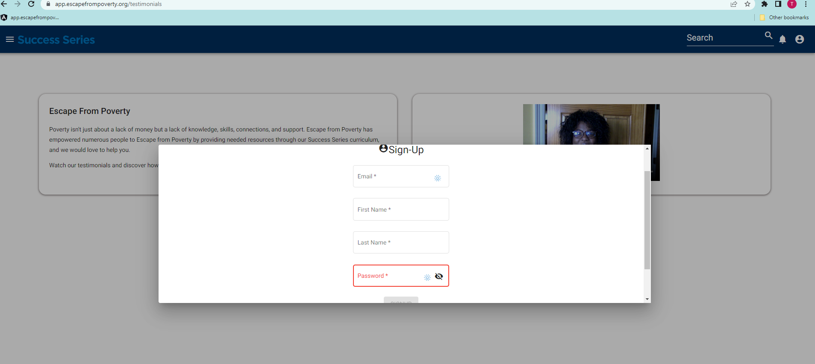
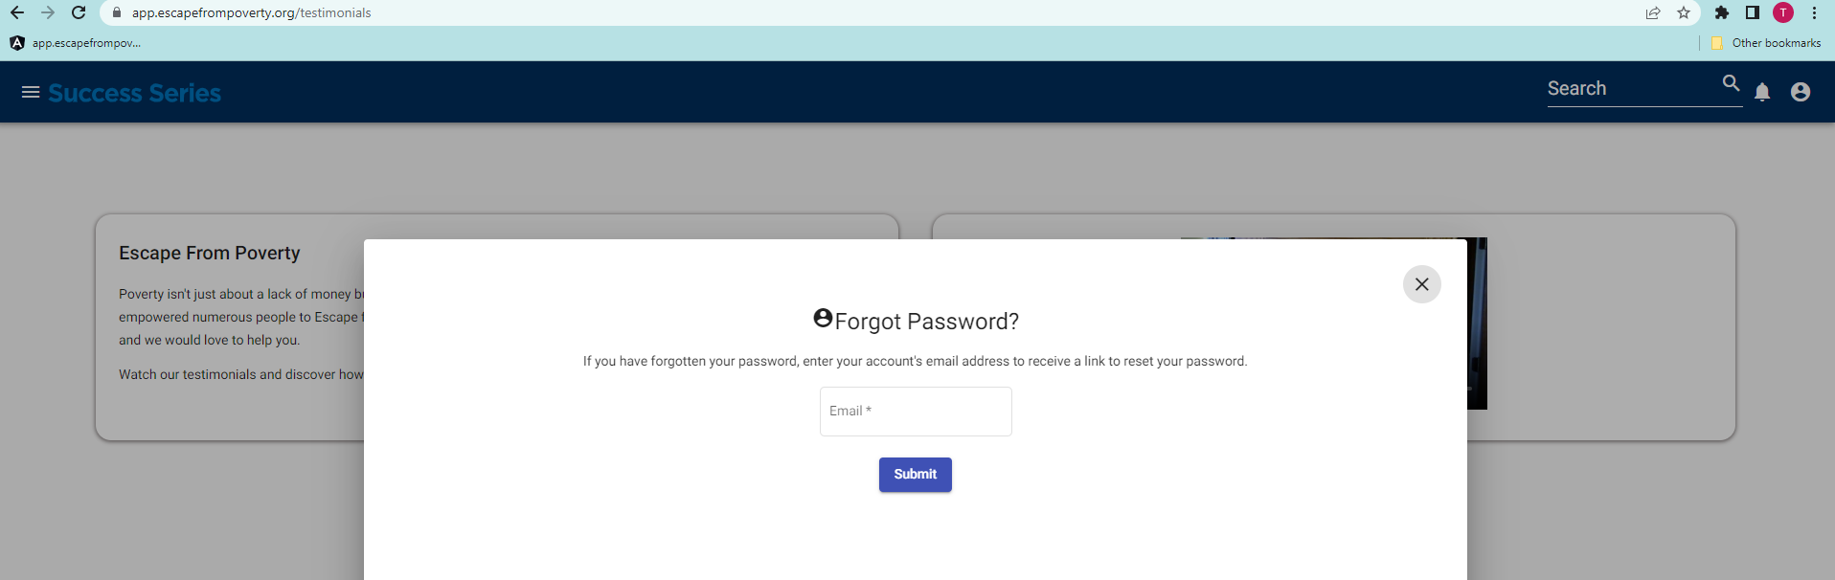

Admin views list of users and user’s roles
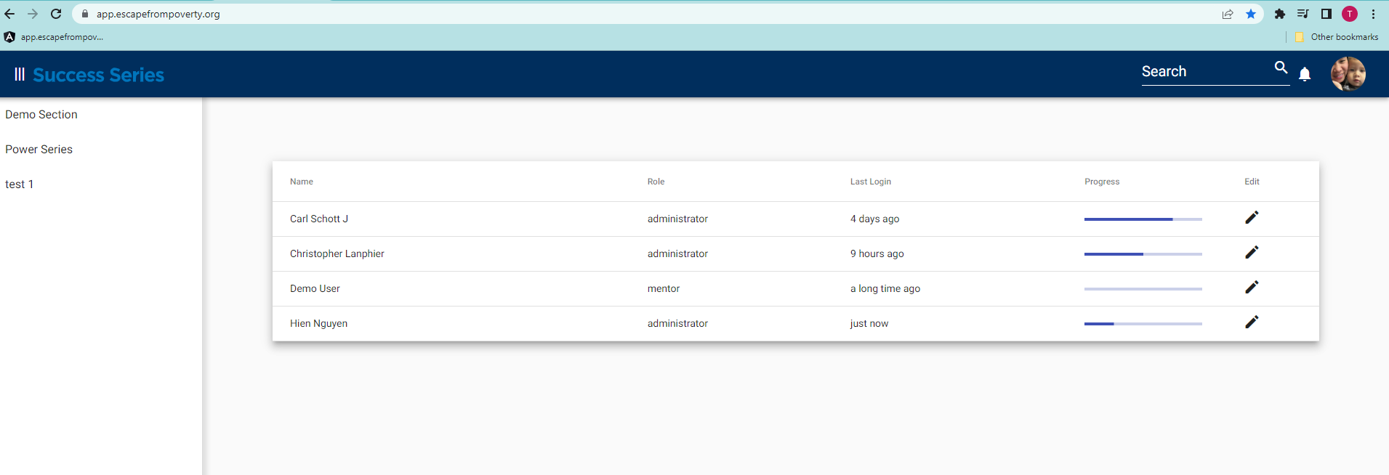

Admin assigns role for user
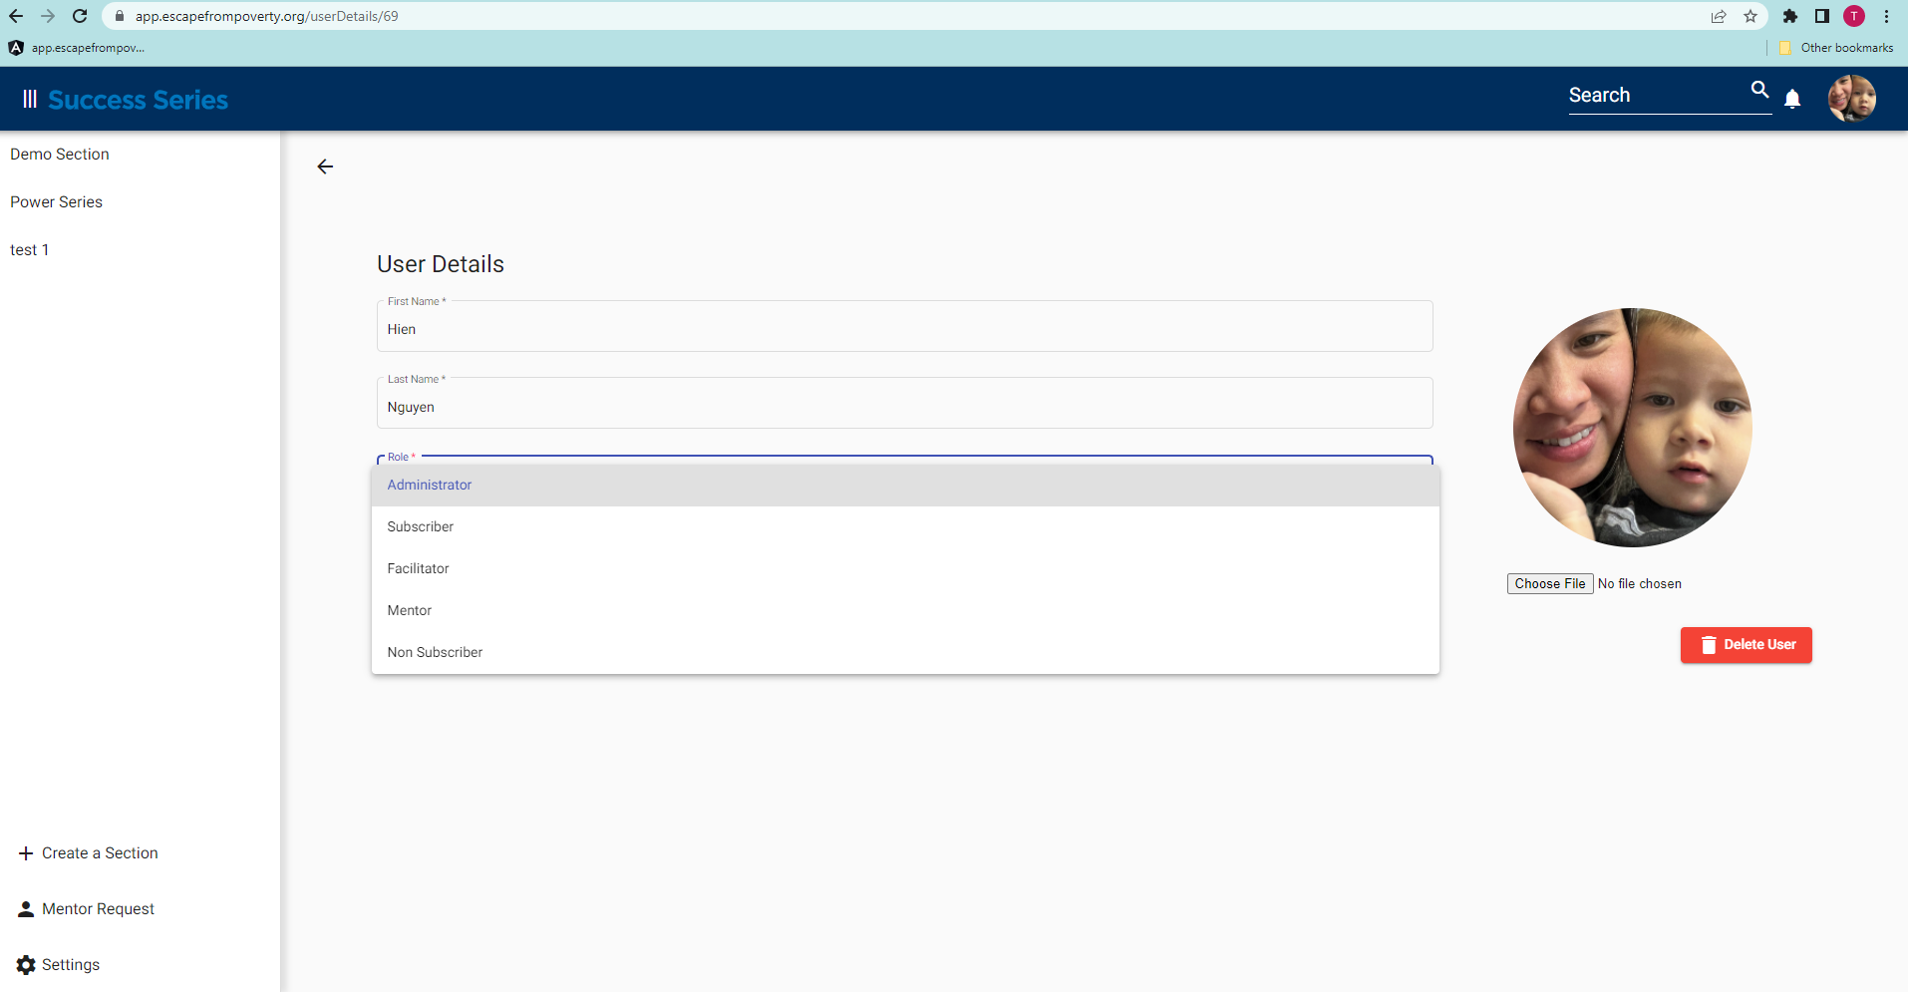

Display Section, Module, Lesson for all user’s roles
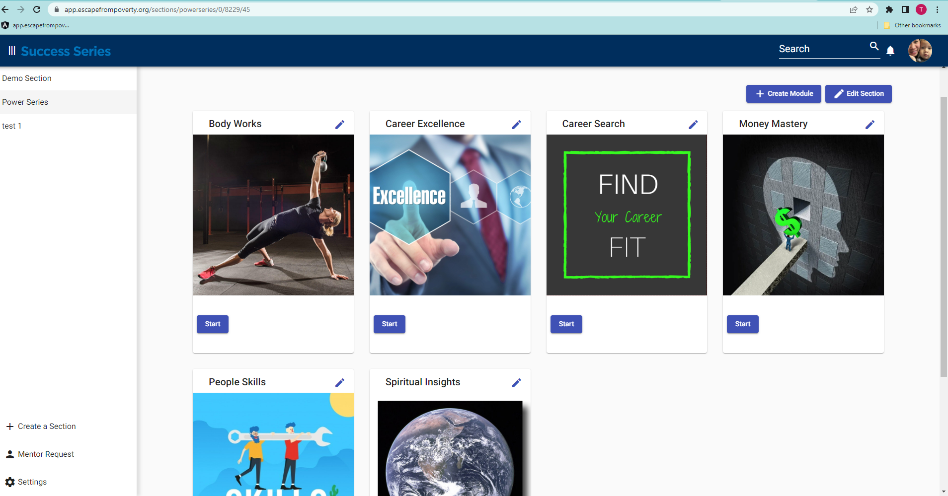

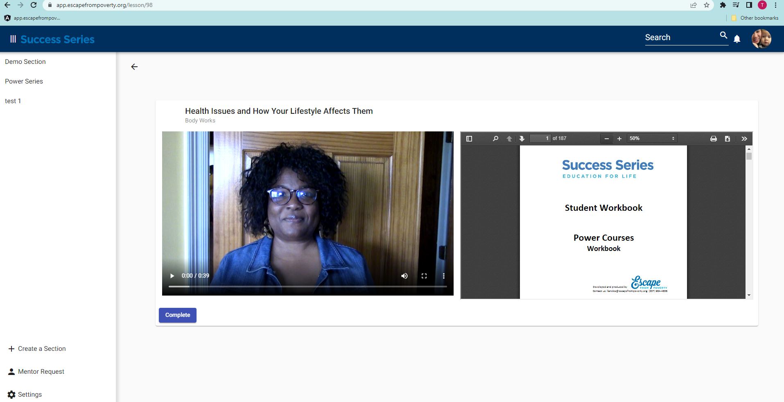

Sprint 4:
Create, edit, delete Sections
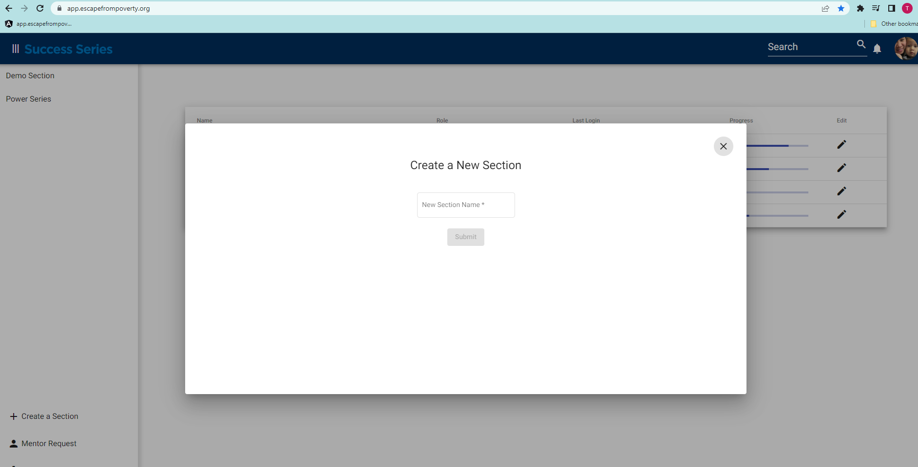
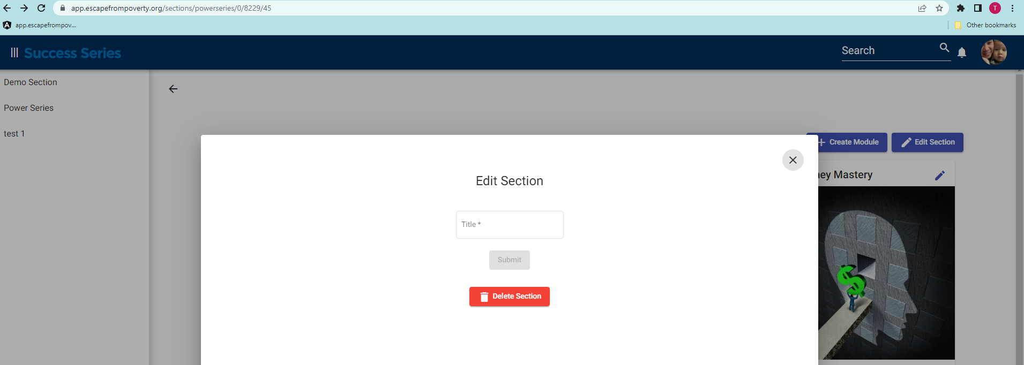

Create, edit, and delete Modules
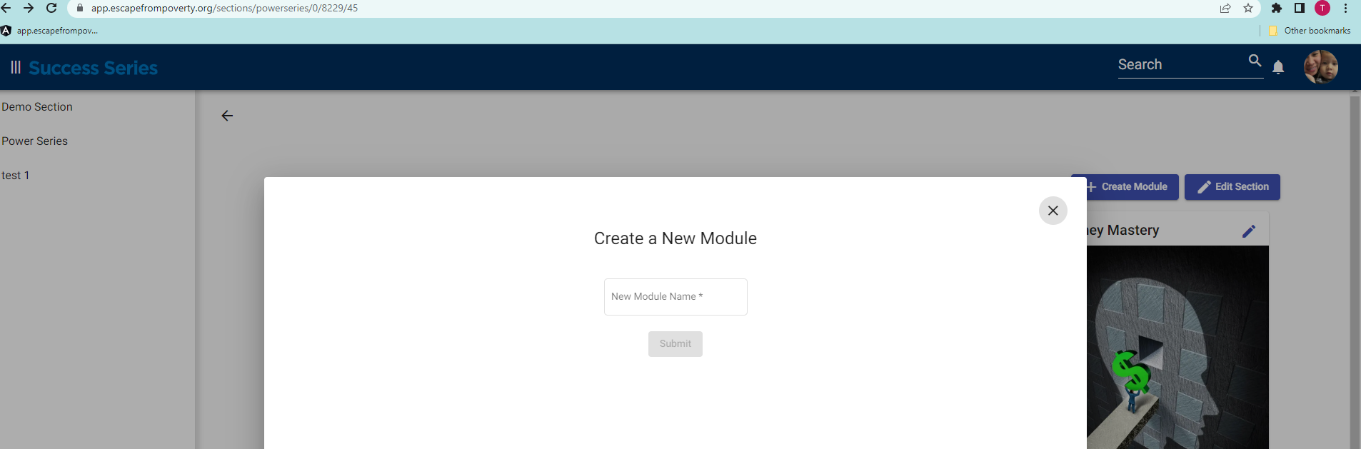
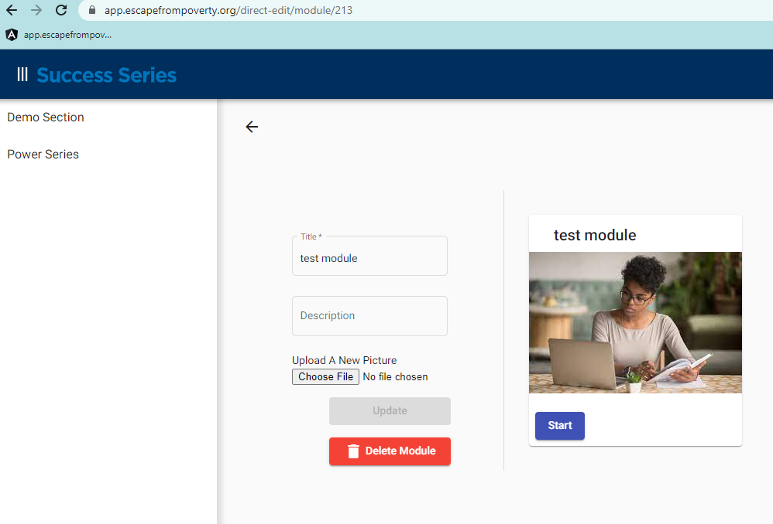

Create, edit and delete Lessons

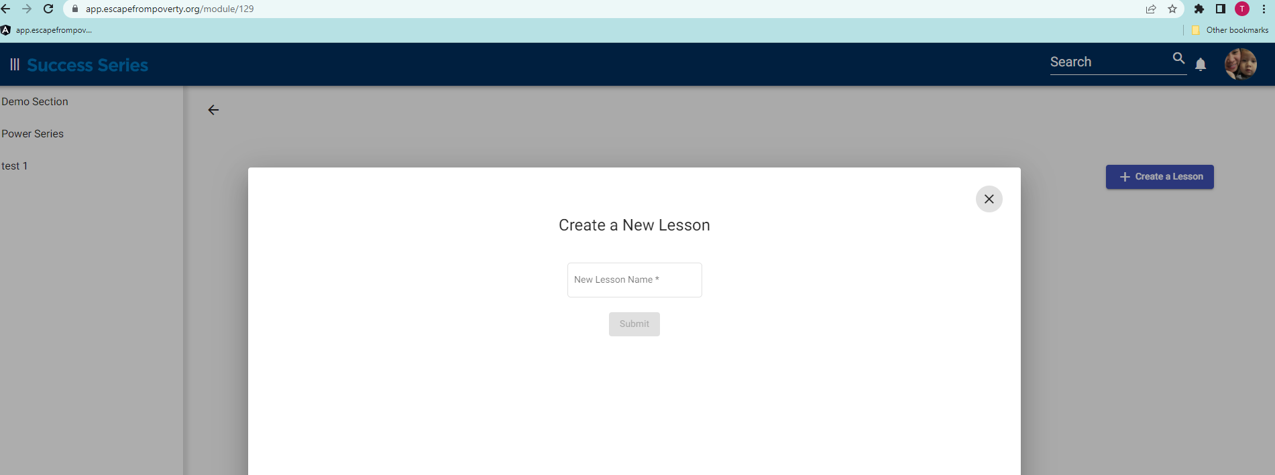

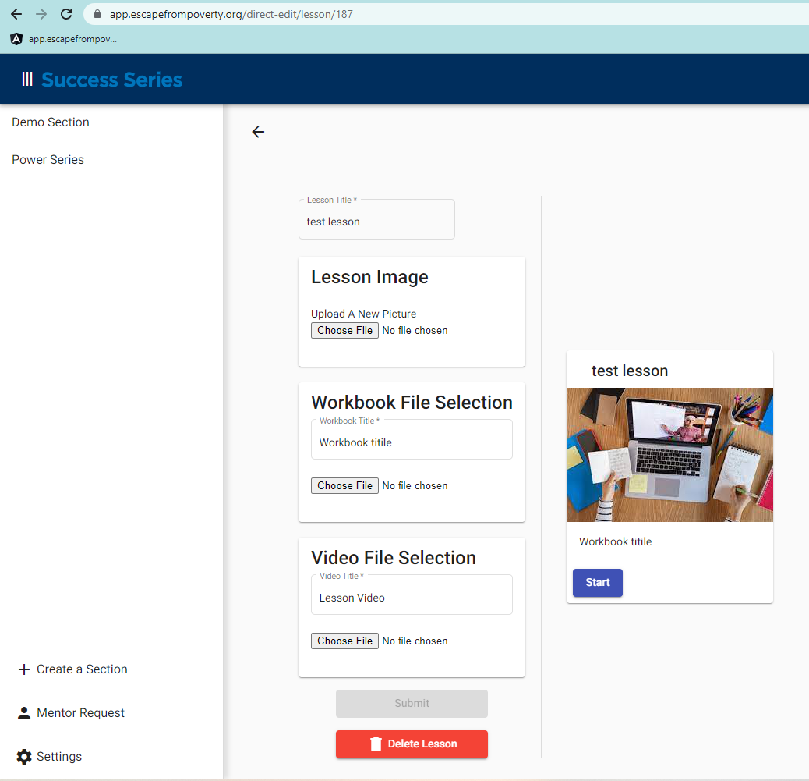

Participant requests mentor
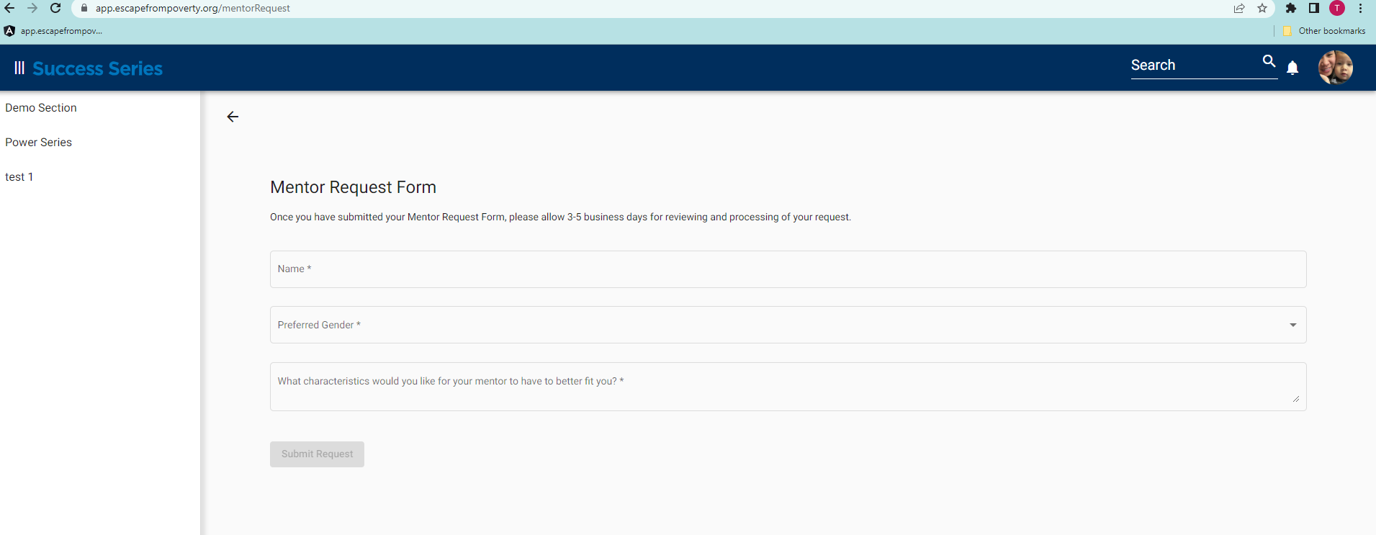
Sprint 5

Undo all the accidental deletes by admin
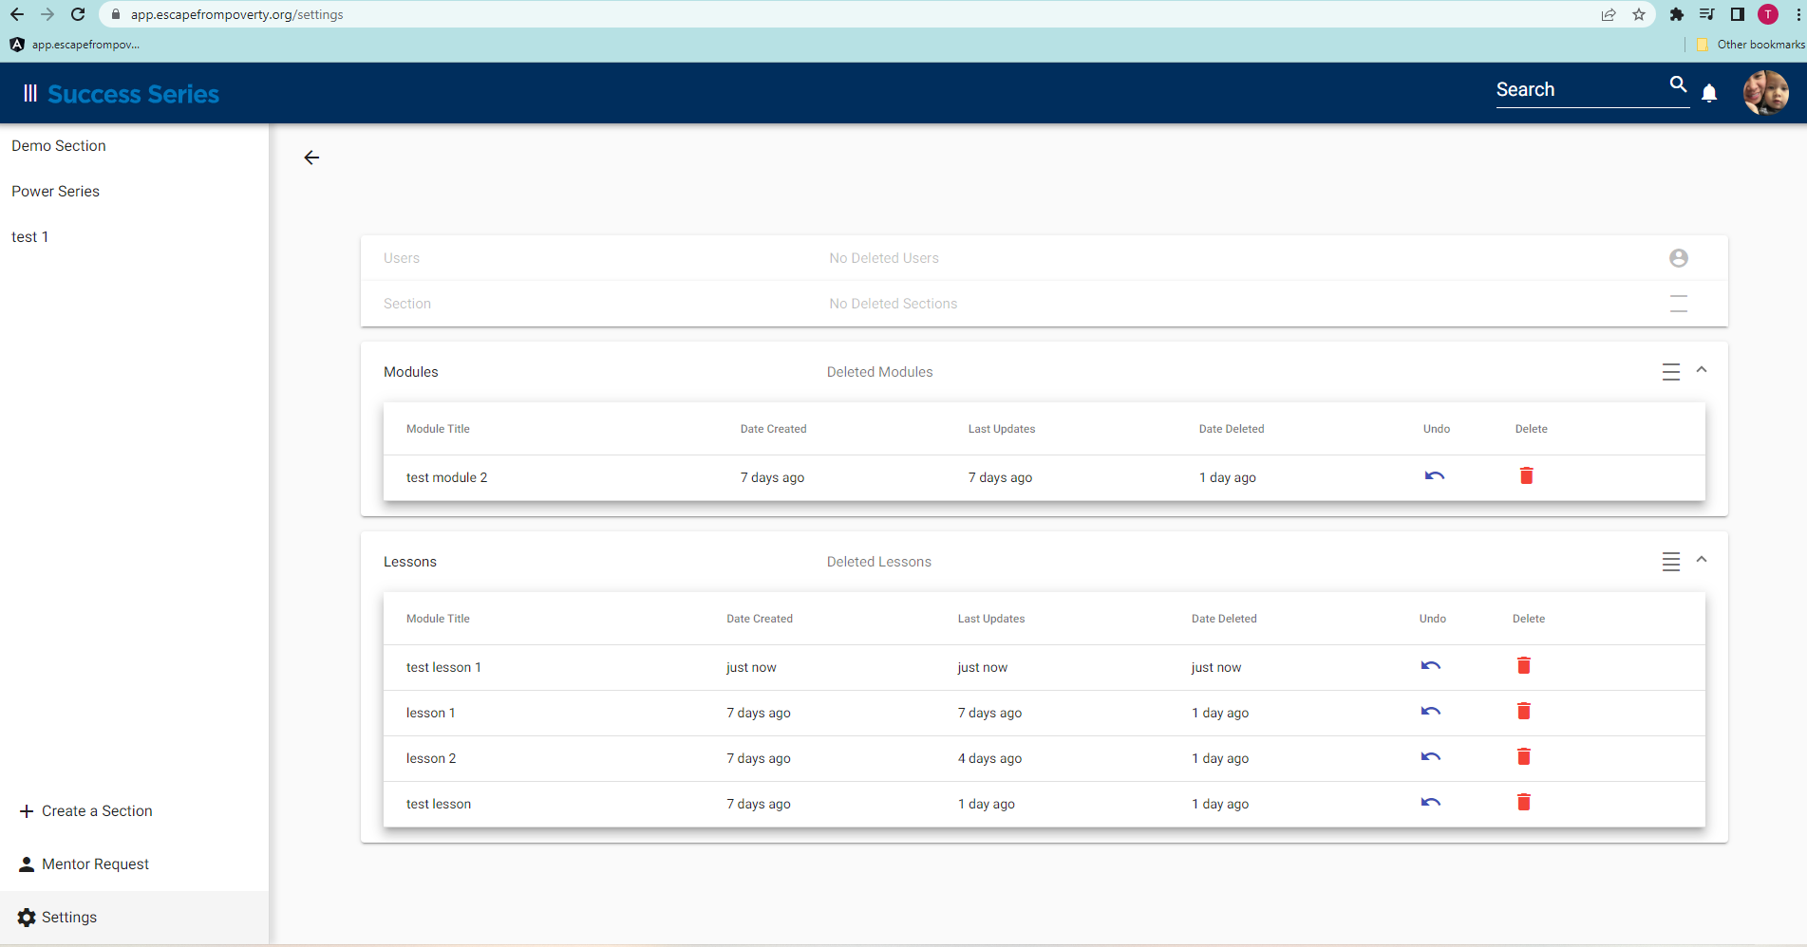

Final Deliverables

All users are able to sign up for an account, login, and reset password when they forget a password.

Admins are able to view all users and assign roles to each user.
Admins are able to create sections, edit and delete Sections, Modules, and Lessons.

Participants are able to view all the lessons inside each Section and each module.
Participants are able to request a mentor for get guidance while in the program.

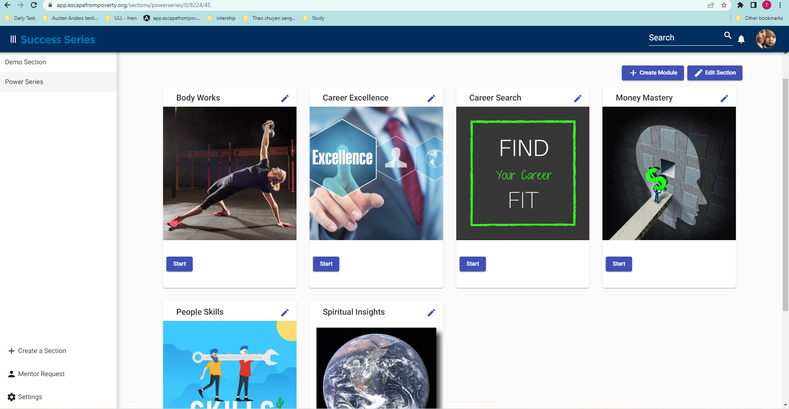

Conclusions
When I deployed the code successfully on the server in the subdomain and I saw our website come to life for the first time, I felt so proud of our team.
Through this project, I learned lots of knowledge that is very useful for my career like Agile. I also got experience working with great tools such as Cypress to automate testing and CI/CD for integration and delivery project code.
Personally, I found this project was challenging but I was lucky to work with Chris and Carl who are great teammates. They are both hardworking, very intelligent and figure things out very quickly. Carl is very patient and enjoyable to work with. Chris is a great leader. I learned a lot from him.
Finally, I had a lot of appreciation for our mentors from CGI. Their involvement contributed a great deal to the success of our project. They spent a lot of time with us to help us understand Agile principles, JIRA, our roles and our individual responsibilities within the team. Because of their advice, we learned to work well with each other as a team.
We learned many valuable lessons. If we have the opportunity to continue working on the project, we plan to add a payment system with which users can choose a subscription for the website. We also would like to implement 2-step verification to better ensure the security of the website. In the future, we hope to continue expanding the website and adding features when needed.

Appendices
Table 1. Project Scope 4
Chart 1. Sprints 6

